1. **Agenda:**
   1. Characteristic of Elliptic Curve.
2. We can perform such operations as point addition and point multiplication.
3. **Point Addition (Scalar Addition)**: When P and Q are distinct points.

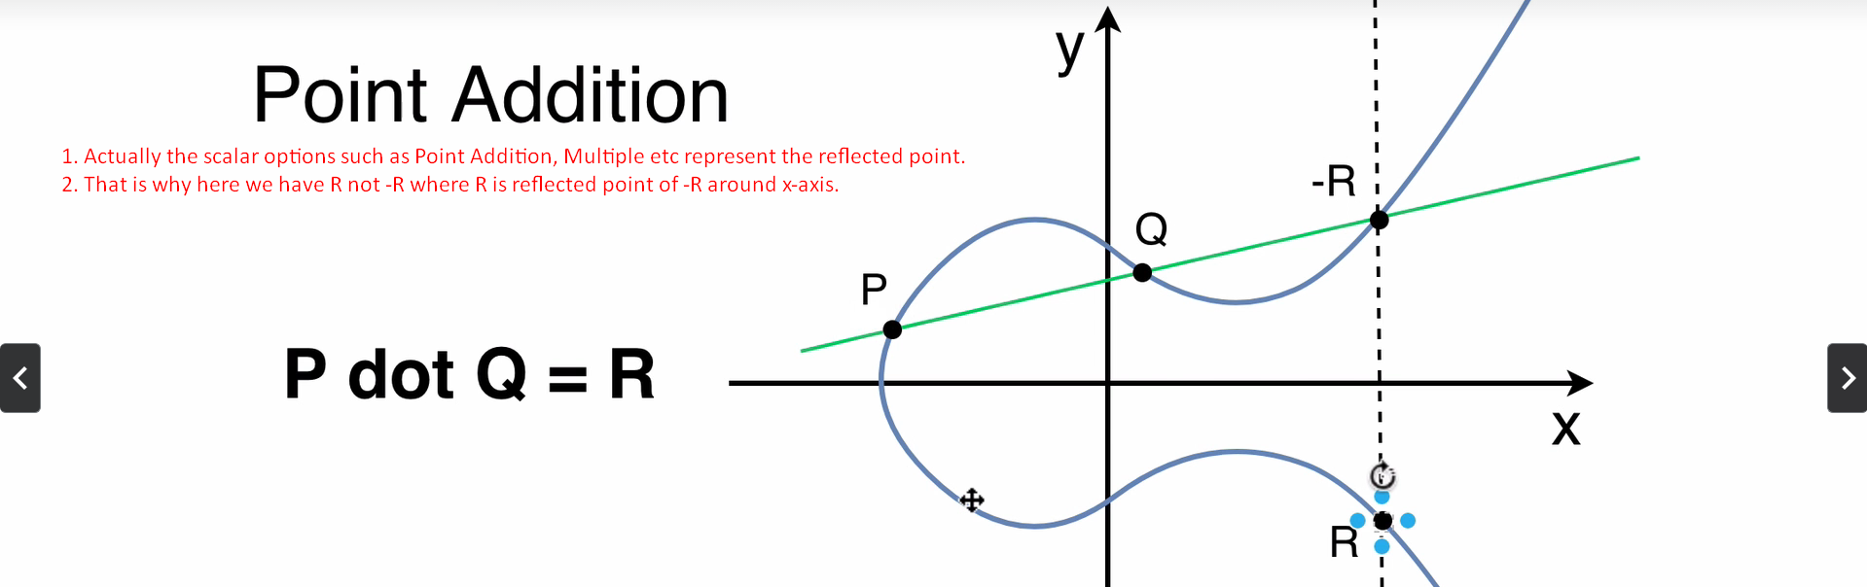

1. **Doubling Points**:
2. In the following diagram, we are joining Q and -R with a line.  
   There must be three points but we have two points.   
   -R is the resultant point which comes after joining two points.   
   It means Q we will count two times means P, Q are same P = Q and we get -R  
   So as per Point Addition we get the following equation in the snapshot.   
   NOTE: Joining P and Q gives -R but in result, we talk about reflected point which is –(-R) around the x-axis.   
   